October 19th^{th} – 21st, 2018 Sheraton Bucks County Hotel, Langhorne, PA

Member/Family Last Name: __________________________ First Name (Adult)___________________________
Address:___________________________________________________City: _______________________________ State:_______________________ Zip:___________________________
Phone Number: _________________________________________
EMAIL: ________________________________________________

Family Member/Caregiver Last Name______________________First Name_______________________Age____
Family Member/Caregiver Last Name______________________First Name_______________________Age____
Family Member/Caregiver Last Name______________________First Name_______________________Age____
Family Member/Caregiver Last Name______________________First Name_______________________Age____

Extended Family & Friends Names: (This information is required for mandatory name badges)

Last Name__________________________ First Name ___________________________ Age____

Last Name__________________________ First Name___________________________ Age____

Last Name__________________________ First Name___________________________ Age____

Last Name__________________________ First Name___________________________ Age____

Chapter Name and District#________________________________________________________
Is this your first LPA conference?___________________________________________________
Any special needs? ________________________________________________________________________

Registration Fees: (All fees must be returned with registration form. PLEASE register early.)

Anyone not active with LPA MUST contact them via info@lpaonline.org or call 1-888-572-2001 to join or reactivate their membership. The National Little People of America web site is: www.lpaonline.org

Early Registration BEFORE September 18th

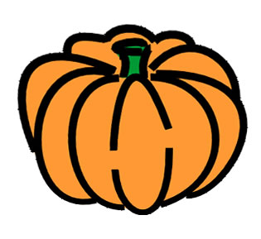
Single $25.00

Family (Immediate) & Caregivers $40.00
Each Extended Family Member or Friend (2yrs and above) - $20.00 # of People x $20

Late Registration BEFORE October 12th

Single $35.00
Family (Immediate) & Caregivers $50.00
Each Extended Family Member or Friend (2yrs+) - $20.00 # of People x 20 :

**Note**: On-Site registration will be charged the Late Registration fee plus an additional $50 fee.

Registration Fee Total: $

Friday Evening: Pre-Teen &Teen Pool and Pizza Party 6:30 to 8:00pm – 11 years or older to attend
Pizza Dinner & Pool Time Fun!
$10 per pre-teen/teen (includes hotel, pizza and beverages) :

# Teens:______

Friday Evening: Welcome Reception 7:00pm – 8:00pm
Adult Ticket: $20
Child Ticket (10 & Under): $10
Newcomers are our guests!
# Adults:________
#Children:________
#Newcomers:________

Friday Evening Ice Cream Social 8:00-9:00pm
$5 per attendee #Attendees:_______

Registration Required for Kids Room: Saturday, October 20th 8:00am-12:00pm
Kids Room- ages 1-10 years old $5.00 # Children________
Saturday: Pre-Teen & Teen Bowling Outing at Bowlero Feasterville
$20 per attendee (11-18 years old) Transportation not included.
Includes bowling, lunch and $5 arcade card. # Attendees: __________

Young Adult Lunch Meet-Up 1:00-3:00pm
Lunch at Margaritas Mexican Restaurant (Across the street from the Sheraton)
Pay on your own (18-22 years old). Need a headcount

Adult (21+ only) Wine Tasting at Rose Bank Winery
$15 per person. Transportation not included.
Includes six wines to taste and four light bites to go along with it. # Attendees:_________

Saturday Evening: Taste of Philadelphia Banquet & Casino Night 7:00 pm to 9:00 pm
Adult Dinner: $25.00 per person Count:________

Child’s Dinner (10 and under) $15.00 per child Count:_________

TOTAL MEMBERS ATTENDING DINNER

Sunday Game Day Breakfast Buffet 8:00-10:00 am
Adult Breakfast: $15.00 per person Count:___________

Child’s Breakfast (10 and under) $10.00 per child Count: ___________
Subtotal $

Add Page 1 & 2 for Total Due: $

NO CASH PLEASE! (KEEP A COPY FOR YOUR RECORDS)
Make CHECK OR MONEY ORDER payable to: “LPA Liberty Chapter”
Please mail your registration form and check only if you can’t go online to:
Amanda Hernandez
815 Red Coat Road Collegeville, PA 19426
lpalibertychapter@gmail.com

Date Received: Check # Amount Received: Amount Owed / Due:

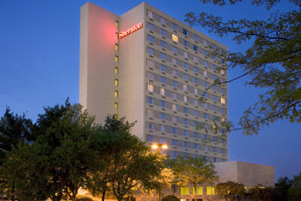

MAKING YOUR HOTEL RESERVATIONS

Sheraton Bucks County Hotel
400 Oxford Valley Road, Langhorne, PA 19047

Phone: 1 (215) 547-4100 Fax: 1 (215) 269-3400

LPA Room Rate $145.00 plus taxes per night

Simply provide the agent our group code “LPA” to get the room rate.

You may also book your room online at https://www.starwoodmeeting.com/events/start.action?id=1805152638&key=CBFD2B

YOU MUST BOOK YOUR ROOM BY SEPTEMBER 24th.

For assistance or any additional questions, please contact:
Danielle Frank at (609) 328-0300 or lpalibertychapter@gmai.com

